# **Name: Abdurrahman Qureshi**

# **Roll no: 210451**

## **Practical no 1: -**

* Exercise

1. **Create ‘student' database and save the database.**

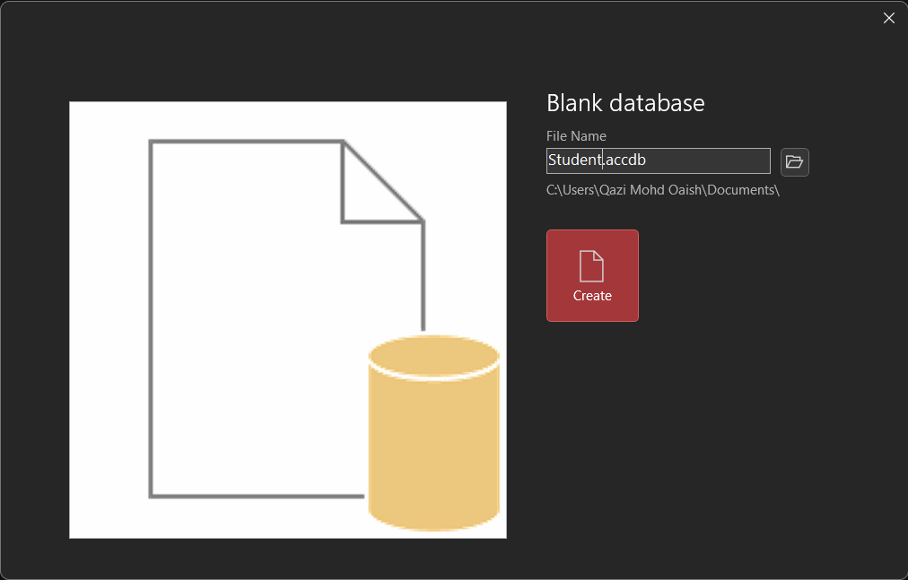

1. **Create Employee database and save it.**

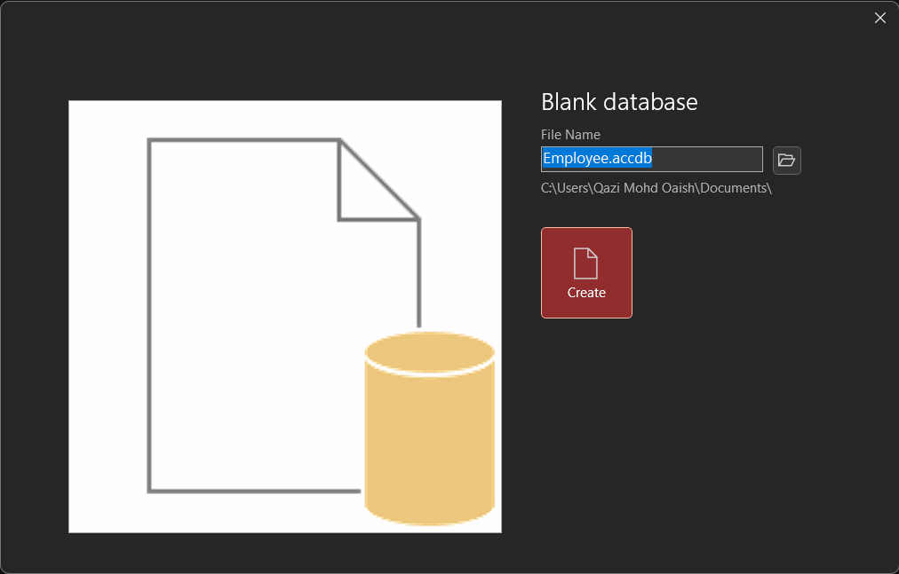

1. **Create multiple tables in database Employee and rename it.**

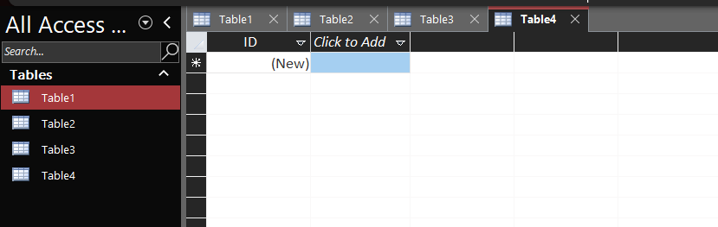

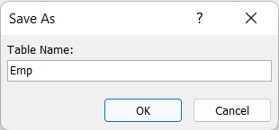

1. **Create multiple tables in database for ‘student' database. View the multiple tables in 'student' database**

